|  |  |
| --- | --- |
| **Assignment Case** |  |
| COMP6183 | COMP6543  Secure Web Programming | Secure Programming |
| **Cyber Security** | **O223-COMP6543-JG02-01** |
| ***Valid on*** *Odd Semester Year 2021/2022* | **Revision 00** |

1. Seluruh mahasiswa tidak diperkenankan untuk:

*All students are not allowed to:*

* + - Berdiskusi dan/atau bekerja sama dengan mahasiswa lainnya

*Discuss and/or work together with other student participants*

* + - Melihat sebagian atau seluruh jawaban mahasiswa lain

*Seeing a part or the whole answer from another student*

* + - Membuka dan menyalin dari **BUKU** atau **CATATAN**, **VIDEO** dari pengajar (recording kelas, VBL, Youtube, dsb) dan **REFERENSI** lainnya

*Open and copy from any resources such as notes, videos (class recording, VBL, Youtube, etc) and other references*

* + - Membuka dan menyalin jawaban dari internet (google, stackoverflow, dsb)

*Open and copy answer from the internet (google, stackoverflow, etc)*

* + - Mengerjakan soal yang tidak sesuai dengan tema yang ada di soal,

*Working with another theme which is not in accordance with the existing theme in the matter of the case,*

* + - Melakukan tindakan kecurangan lainnya,

*Committing other dishonest actions,*

* + - Secara sengaja maupun tidak sengaja melakukan segala tindakan kelalaian yang menyebabkan hasil karyanya berhasil dicontek oleh orang lain / kelompok lain.

*Accidentally or intentionally conduct any failure action that cause the results of the project was copied by someone else / other groups.*

1. Jika mahasiswa terbukti melakukan tindakan seperti yang dijelaskan butir 1 di atas, maka **nilai mahasiswa** yang melakukan kecurangan (menyontek maupun dicontek) akan di – **NOL** – kan.

*If the student is proved to the actions described in point 1 above, the score of the student which committed dishonest acts (cheating or being cheated) will be “Zero”*

1. Perhatikan jadwal pengumpulan jawaban, segala jenis pengumpulan jawaban di luar jadwal tidak dilayani.

*Pay attention to the submission schedule, all kinds of submission outside the schedule will not be accepted*

1. Bila Anda tidak membaca peraturan ini, maka Anda dianggap telah membaca dan menyetujuinya

*If you have missed to read these regulations, so you are considered to have read and agreed on it*

1. Persentase penilaiaan untuk matakuliah ini adalah sebagai berikut:

*Marking percentage for this subject is described as follows:*

|  |
| --- |
| **Tugas Mandiri**  *Assignment* |
| 100% |

1. Software yang digunakan pada matakuliah ini adalah sebagai berikut:

*Software will be used in this subject are described as follows:*

|  |
| --- |
| **Software**  *Software* |
| Chrome / Firefox / Microsoft Edge  Visual Studio Code  XAMPP 8.0.7  jQuery 3.6.0 |

## Ekstensi file yang harus disertakan dalam pengumpulan tugas mandiri untuk matakuliah ini adalah sebagai berikut:

*File extensions should be included in assignment collection for this subject are described as follows:*

|  |
| --- |
| **Tugas Mandiri**  *Assignment* |
| PHP, HTML, CSS, JS, SQL, Image Files (JPG / PNG), HTACCESS |

## Soal

*Case*

**GoGame**

**GoGame** is a website that full of information about game, but **the website needs** **more maintenance**. **You are tasked to** **maintain that website**.The following are the website’s requirements:

1. **Home Page (index.php)**
   * + This page can be accessed by anybody.
     + Show the following **navigation menu** for **guest**:
       - GoGame(it will navigate to home page)
       - Login
     + Show the following **navigation menu** for **user**:
       - GoGame(it will navigate to home page)
       - Post Game
       - Log out
     + The **log out** menu will **destroy the user’s session** and **generate a new session id**.
     + Show Every Post from the database with the following information:

* **Title of the game**
* **Difficulty of the game**
* **Description of the game**
* **Image of the game**
  + - Show **Delete Button** if user has **logged in**.

**Figure 1. Home Page for Guests**

**Figure 2. Home Page If User Has Logged In**

1. **Login Page (login.php)**
   * + This page **can only be accessed by guests**, if logged in user access this page, **redirect** them to **home page.**
     + This page contains of a form with the following component:

* Username Textbox
* Password Textbox
* Login Button
  + - If the user clicks on the Login button, then validate:
* If **Username and Password** field is **empty**, then show “**username and password cannot be empty**” error message.
* If **Username** field is **empty**, then show “**username cannot be empty**” error message.
* If **Password** field is **empty**, then show “**password cannot be empty**” error message.
* If the **Username or Password** user input **does not match** with the **data in database** then show “**You have entered your username or password incorrectly**” error message.
* The following are **credentials** already stored in the database:

|  |  |
| --- | --- |
| Username | Password |
| Budi | AllAboutBudi |
| NobodyKnowMe | PleaseDontTell |
| TryHard | KillMeNow |

* + - If user successfully logged in, then the **user information will be stored in a session** and after that, **user will be redirected to Home Page.**
    - **Generate new session id** after the user **has successfully logged in.**
    - If here is an **error** during the **login process**, then **display the error message** inthe **Login page as shown** in Figure 3.

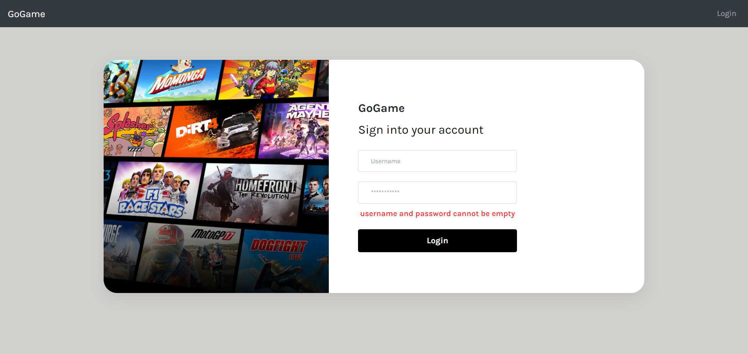

**Figure 3. Log In Error Message**

1. **Post Game Page (postGame.php)**

* This Page can only **be accessed if user has logged in.**
  + - This page contains of a form with the following component:
* Title Textbox
* Description Textbox
* Difficulty with radio button selection
* Image file chooser
* Post Game Button
  + - If the user clicks on the Post button, then validate:
* If **Title** is **empty**, show “**Title should not be empty**” error message.
* If **Title** **already exists**, show “**Title has already existed**” error message.
* If **Description** is **empty**, then show “**Description should not be empty**” error message.
* If **Description** is **less than 15 characters**, then show “**Description must be more than 15 characters**” error message.
* If **Description** is **more than 250 characters**, then show “**Description must be less than 250 characters**” error message.
* If **Difficulty** is **not selected**, then show “**You should choose the difficulty**” error message.
* Allowed File Extensions: **.jpg, .jpeg, .png**
* If **file extension is not among allowed file extensions**, show “**File Extension Must be 'jpg' or 'png' or 'jpeg'!**” error message.
* If **file size** **more than 2MB**, then show “**Image Size Must Not be More Than 2MB !**” error message.
* If there is no error, make sure data is **inserted in the database** and the **File must be stored in the server.**

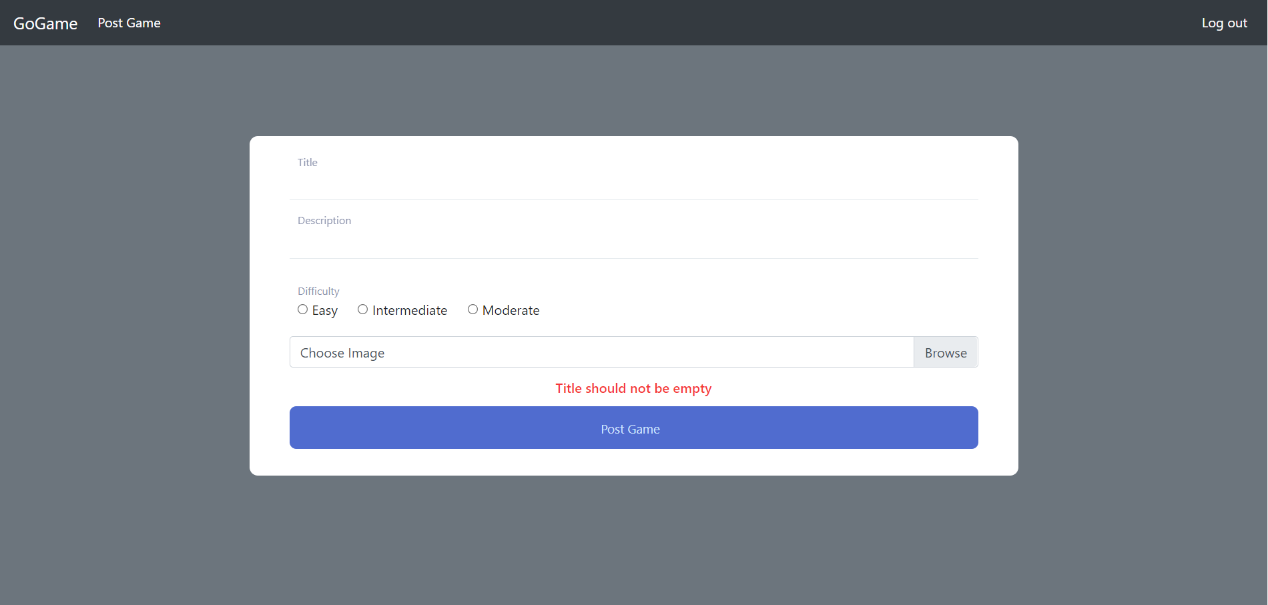

**Figure 4. Title Error Message**

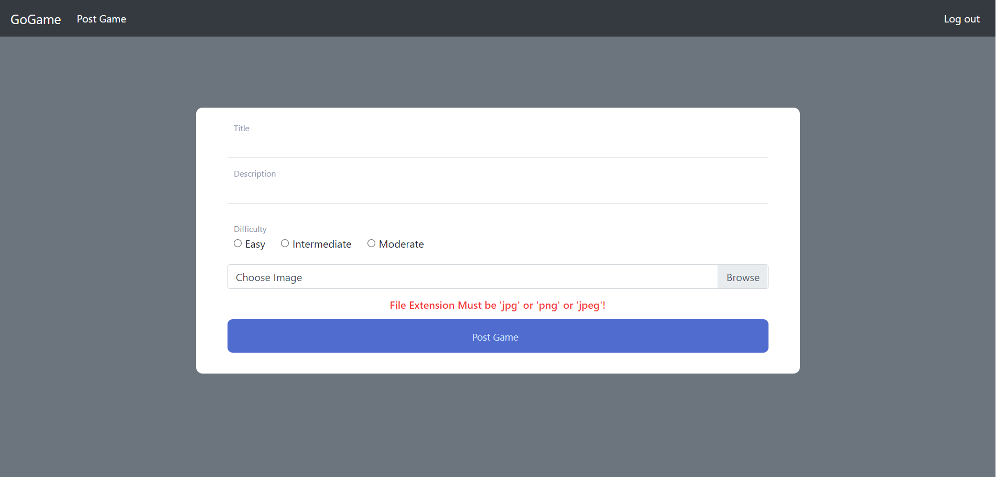

**Figure 5. File Extension Error Message**

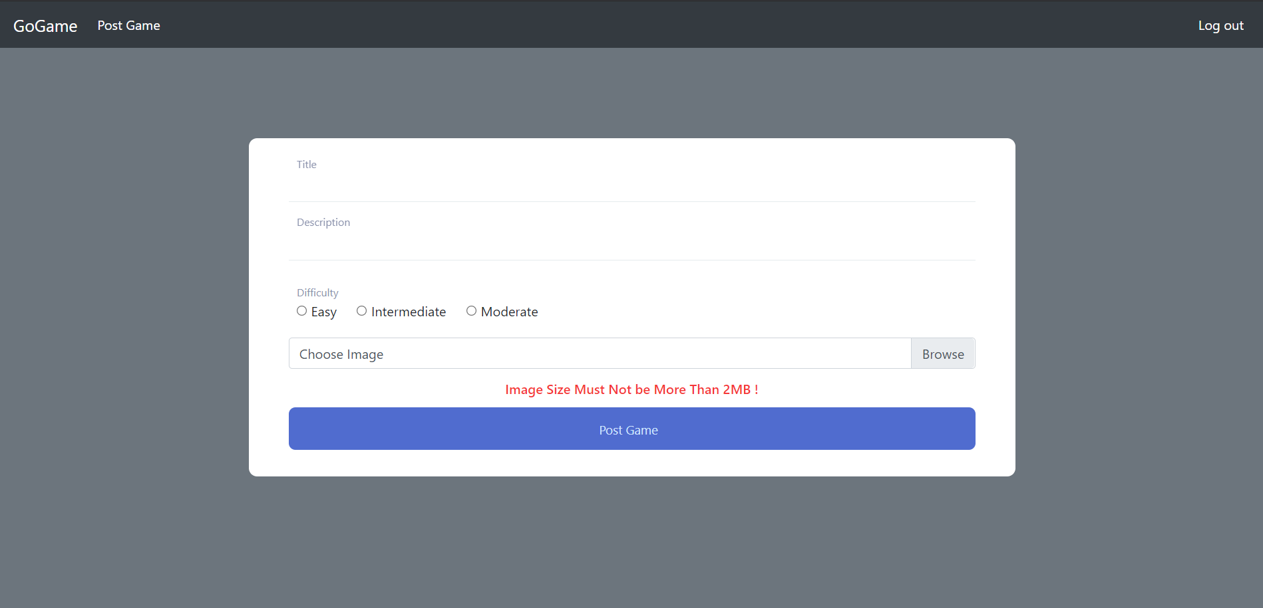

**Figure 6. Image Size Error Message**

**If there is something you don’t understand, feel free to ask your Assistant!**